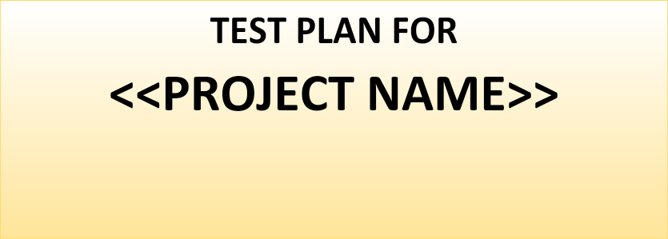

*ChangeLog*

|  |  |  |  |
| --- | --- | --- | --- |
| **Version** | **Change Date** | **By** | **Description** |
| version number | Date of Change | Name of person who made changes | Description of the changes made |
|  |  |  |  |
|  |  |  |  |

**1** **INTRODUCTION 2**

1.1 Scope 2

*1.1.1* *In Scope 2*

*1.1.2* *Out of Scope 2*

1.2 Quality Objective 2

1.3 Roles and Responsibilities 2

**2** **TEST METHODOLOGY 3**

2.1 Overview 3

2.2 Test Levels 3

2.3 Bug Triage 3

2.4 Suspension Criteria and Resumption Requirements 3

2.5 Test Completeness 4

**3** **TEST DELIVERABLES 4**

**4** **RESOURCE & ENVIRONMENT NEEDS 4**

4.1 Testing Tools 4

4.2 Test Environment 4

**5** **TERMS/ACRONYMS 5**

# **Introduction**

Brief introduction of the test strategies, process, workflow and methodologies used for the project

## **Scope**

### In Scope

Scope defines the features, functional or non-functional requirements of the software that **will be** tested

### Out of Scope

Out Of Scope defines the features, functional or non-functional requirements of the software that **will NOT be** tested

## **Quality Objective**

Here make a mention of the overall objevtie that you plan to achive withou your testing

Some objectives of your testing project could be

* Ensure the Application Under Test conforms to functional and non-functional requirements
* Ensure the AUT meets the quality specifications defined by the client
* Bugs/issues are identified and fixed before go live

## **Roles and Responsibilities**

Detail description of the Roles and responsibilities of different team members like

* QA Analyst
* Test Manager
* Configuration Manager
* Developers
* Installation Team

Amongst others

# **Test Methodology**

## **Overview**

Mention the reason of adopting a particular test methodology for the project. The test methodology selected for the project could be

* WaterFall
* Iterative
* Agile
* Extreme Programming

The methodology selected depends on multiple factors. You can read about Test Methodology [here](http://www.guru99.com/testing-methodology.html)

## **Test Levels**

**Test Levels define the Types of Testing to be executed on the Application Under Test (AUT**). The Testing Levels primarily depends on the scope of the project, time and budget constraints.

## **Bug Triage**

The goal of the triage is to

* To define the type of resolution for each bug
* To prioritize bugs and determine a schedule for all “To Be Fixed Bugs’.

## **Suspension Criteria and Resumption Requirements**

Suspension criteria define the criteria to be used to suspend all or part of the testing procedure while Resumption criteria determine when testing can resume after it has been suspended

## **Test Completeness**

Here you define the criterias that will deem your testing complete.

For instance, a few criteria to check Test Completeness would be

* 100% test coverage
* All Manual & Automated Test cases executed
* All open bugs are fixed or will be fixed in next release

# **Test Deliverables**

Here mention all the Test Artifacts that will be delivered during different phases of the testing lifecycle.

Here are the sample deliverables

|  |
| --- |
| * Test Plan * Test Cases * Requirement Traceability Matrix * Bug Reports * Test Strategy * Test Metrics * Customer Sign Off |

# **Resource & Environment Needs**

## **Testing Tools**

Make a list of Tools like

* Requirements Tracking Tool
* Bug Tracking Tool
* Automation Tools

Required to test the project

## **Test Environment**

It mentions the minimum **hardware** requirements that will be used to test the Application.

Following **software’s** are required in addition to client-specific software.

* Windows 8 and above
* Office 2013 and above
* MS Exchange, etc.

# **Terms/Acronyms**

Make a mention of any terms or acronyms used in the project

|  |  |
| --- | --- |
| **TERM/ACRONYM** | **DEFINITION** |
| API | Application Program Interface |
| AUT | Application Under Test |